Task 1:
Basic DHCP Server & Dual-Client PC Configuration in Cisco Packet Tracer

Objective: Set up a local network in Cisco Packet Tracer containing one dedicated DHCP Server and two Client PCs, configure the dynamic IP address pool, and verify dynamic network parameter allocation on both hosts.

1. Network Topology & Equipment:
- 1x Central Switch: Cisco Catalyst 2960
- 1x Server: Generic Server (acting as DHCP Server)
- 2x End Devices: PC0 and PC1
- Cabling: Ethernet Straight-Through cables connecting all devices to switch FastEthernet ports.

2. Step-by-Step Packet Tracer Configuration:
Step A: Server Static IP Configuration
- Click on Server0 $→$ Desktop tab $→$ IP Configuration.
- Select Static and set:
  - IP Address: 192.168.1.1
  - Subnet Mask: 255.255.255.0
  - Default Gateway: 192.168.1.1
Step B: Configuring DHCP Service on Server
- Open Server0 $→$ Services tab $→$ Select DHCP.
- Toggle Service to ON.
- Configure the Pool Parameters:
  - Pool Name: serverPool
  - Default Gateway: 192.168.1.1
  - DNS Server: 8.8.8.8
  - Start IP Address: 192.168.1.10
  - Subnet Mask: 255.255.255.0
  - Maximum number of Users: 50
- Click Save.
Step C: Verification on Client PCs
- Open PC0 $→$ Desktop $→$ IP Configuration $→$ Select DHCP.
  - Result: "DHCP request successful." Received IP: 192.168.1.10
- Open PC1 $→$ Desktop $→$ IP Configuration $→$ Select DHCP.
  - Result: "DHCP request successful." Received IP: 192.168.1.11

3. Dynamic IP Verification Results Table:

Device Name | Connection Type | IP Allocation Mode | Assigned IP Address | Subnet Mask | Default Gateway | Verification Status
Server0 | FastEthernet0/1 | Static | 192.168.1.1 | 255.255.255.0 | 192.168.1.1 | Active Server
PC0 | FastEthernet0/2 | DHCP | 192.168.1.10 | 255.255.255.0 | 192.168.1.1 | SUCCESS
PC1 | FastEthernet0/3 | DHCP | 192.168.1.11 | 255.255.255.0 | 192.168.1.1 | SUCCESS

Task 2:
DHCP DORA Process Sequence Diagram & Flow Analysis

Objective: Illustrate and document the 4-step DHCP handshake (DORA: Discover, Offer, Request, Acknowledge) sequence diagram, identifying message directionality, source/destination ports, and packet transmission types.

1. DHCP DORA Process Sequence Diagram:

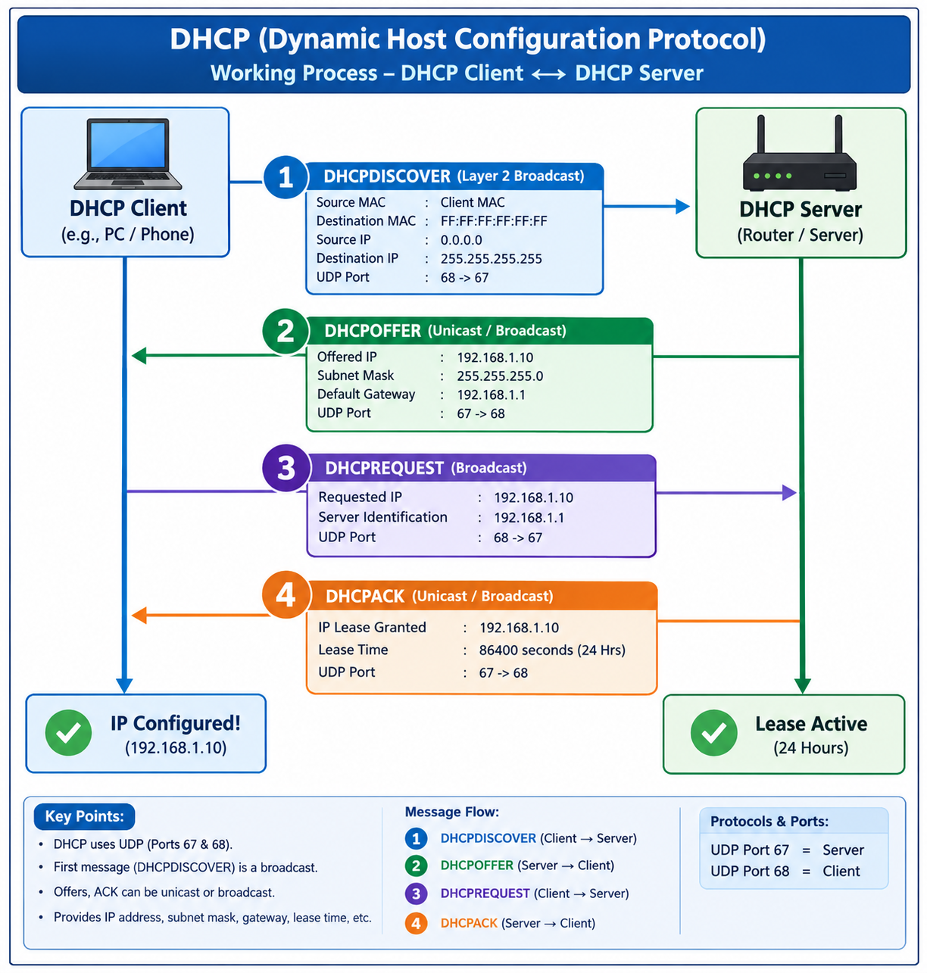
2. Detailed Step-by-Step Breakdown:
1.DHCPDISCOVER (Sender: Client -:Step 1: Discover.
Receiver: Server)">
- Transmission Type: Broadcast (255.255.255.255)
- Description: The unconfigured client host sends a broadcast packet across the network searching for an active DHCP server to request IP assignment.
2.DHCPOFFER (Sender: Server -:Step 2: Offer.
Receiver: Client)">
- Transmission Type: Unicast / Broadcast
- Description: The DHCP server responds by offering an available IP address (192.168.1.10), subnet mask (255.255.255.0), default gateway, and DNS servers.
3.DHCPREQUEST (Sender: Client -:Step 3: Request.
Receiver: Server)">
- Transmission Type: Broadcast
- Description: The client formally accepts the offered IP address and broadcasts a request to bind that specific IP address from the server.
4.DHCPACK (Sender: Server -:Step 4: Acknowledge.
Receiver: Client)">
- Transmission Type: Unicast / Broadcast
- Description: The server sends a final acknowledgment packet confirming the IP binding and lease duration, completing the host configuration.

Task 3:
DHCP Address Pool Exhaustion & APIPA Behavior Simulation

Objective: Constrain the active DHCP server address pool size to a single available host IP (192.168.1.10), connect two client hosts (PC0 & PC1), observe address allocation failure, and document the root cause for APIPA fallback.

1. Server Pool Configuration Modifications:
- Server Management Interface: Server0 $→$ Services $→$ DHCP
- Start IP Address: 192.168.1.10
- Maximum Number of Users: 1 (Pool Range: 192.168.1.10 - 192.168.1.10)

2. Dual Client Connection Results Table:

Host Device | IP Request Status | Assigned IP Address | Subnet Mask | Allocation Mechanism / Status
PC0 (First Device Connected) | SUCCESS | 192.168.1.10 | 255.255.255.0 | Successfully leased sole active IP from DHCP Server.
PC1 (Second Device Connected) | FAILED | 169.254.182.41 | 255.255.0.0 | APIPA Fallback (DHCP Pool Exhausted)

3. Technical Explanation (2-3 Lines):
Why Only One PC Succeeds: The DHCP server pool was explicitly limited to assign only 1 single IP address (192.168.1.10). When PC0 requested an IP first, it consumed the only available lease in the pool; consequently, when PC1 sent its DHCPDISCOVER broadcast, the server could not issue a DHCPOFFER due to DHCP Pool Exhaustion, forcing PC1 to automatically assign itself an unroutable APIPA (Automatic Private IP Addressing) address in the 169.254.0.0/16 range.

Task 4:
Restaurant Wi-Fi Simulation & Public DHCP Allocation

Objective: Simulate a public restaurant Wi-Fi environment in Cisco Packet Tracer where a DHCP server dynamically provides IP addresses, Subnet Masks, Default Gateways, and DNS details to customer end devices (Laptop and Smartphone).

1. Network Topology Setup:
- Central Gateway Device: Wireless Router (e.g., WRT300N / Home Router with integrated DHCP Server)
- Connected Customer Devices:
  - Device A: Laptop (Laptop-Customer1) connected via Wi-Fi/Wireless
  - Device B: Generic PC (configured as Smartphone-Customer2) connected via Wireless / Switch Interface
- Wi-Fi SSID / Security: Zomato_Guest_WiFi (Open / WPA2-PSK)

2. Router DHCP Service Configuration:
- Router Management IP: 192.168.1.1
- DHCP Address Pool: 192.168.1.100 to 192.168.1.200
- Subnet Mask: 255.255.255.0
- Default Gateway: 192.168.1.1
- DNS Server: 8.8.8.8

3. Assigned IP Addresses Verification Table:

Customer Device | Device Type | Connection Interface | IP Mode | Assigned IP Address | Subnet Mask | Default Gateway | Status
Laptop-Customer1 | Laptop | Wireless (802.11n) | DHCP | 192.168.1.100 | 255.255.255.0 | 192.168.1.1 | Connected & Active
Smartphone-Customer2 | Generic PC | Wireless / FastEthernet | DHCP | 192.168.1.101 | 255.255.255.0 | 192.168.1.1 | Connected & Active

4. Why DHCP is Crucial in a Restaurant / Public Wi-Fi Environment:
1.Seamless Guest Onboarding:1. Zero User Configuration.
- Customers visiting a restaurant want to connect to Wi-Fi instantly without technical knowledge.
- DHCP automatically configures IP address, gateway, and DNS on their device as soon as they join the SSID.
2.Dynamic IP Lease Recycling:2. High Device Turnover Management.
- Hundreds of customers enter and leave a restaurant daily.
- Short DHCP lease times (e.g., 30–60 minutes) ensure that when a customer leaves, their assigned IP address is freed and recycled for new incoming guests.
3.Centralized Pool Control:3. IP Address Conflict Prevention.
- Manual static IP assignment in a public network would lead to frequent duplicate IP collisions.
- DHCP centrally manages the address space, guaranteeing every connected phone or laptop gets a unique IP address.

